A Reliable and Secure Crowdfunding Platform Using Decentralized Blockchain

Proposed Crowdfunding Platform and Implementation Stapes:

Step 1: Proposed System

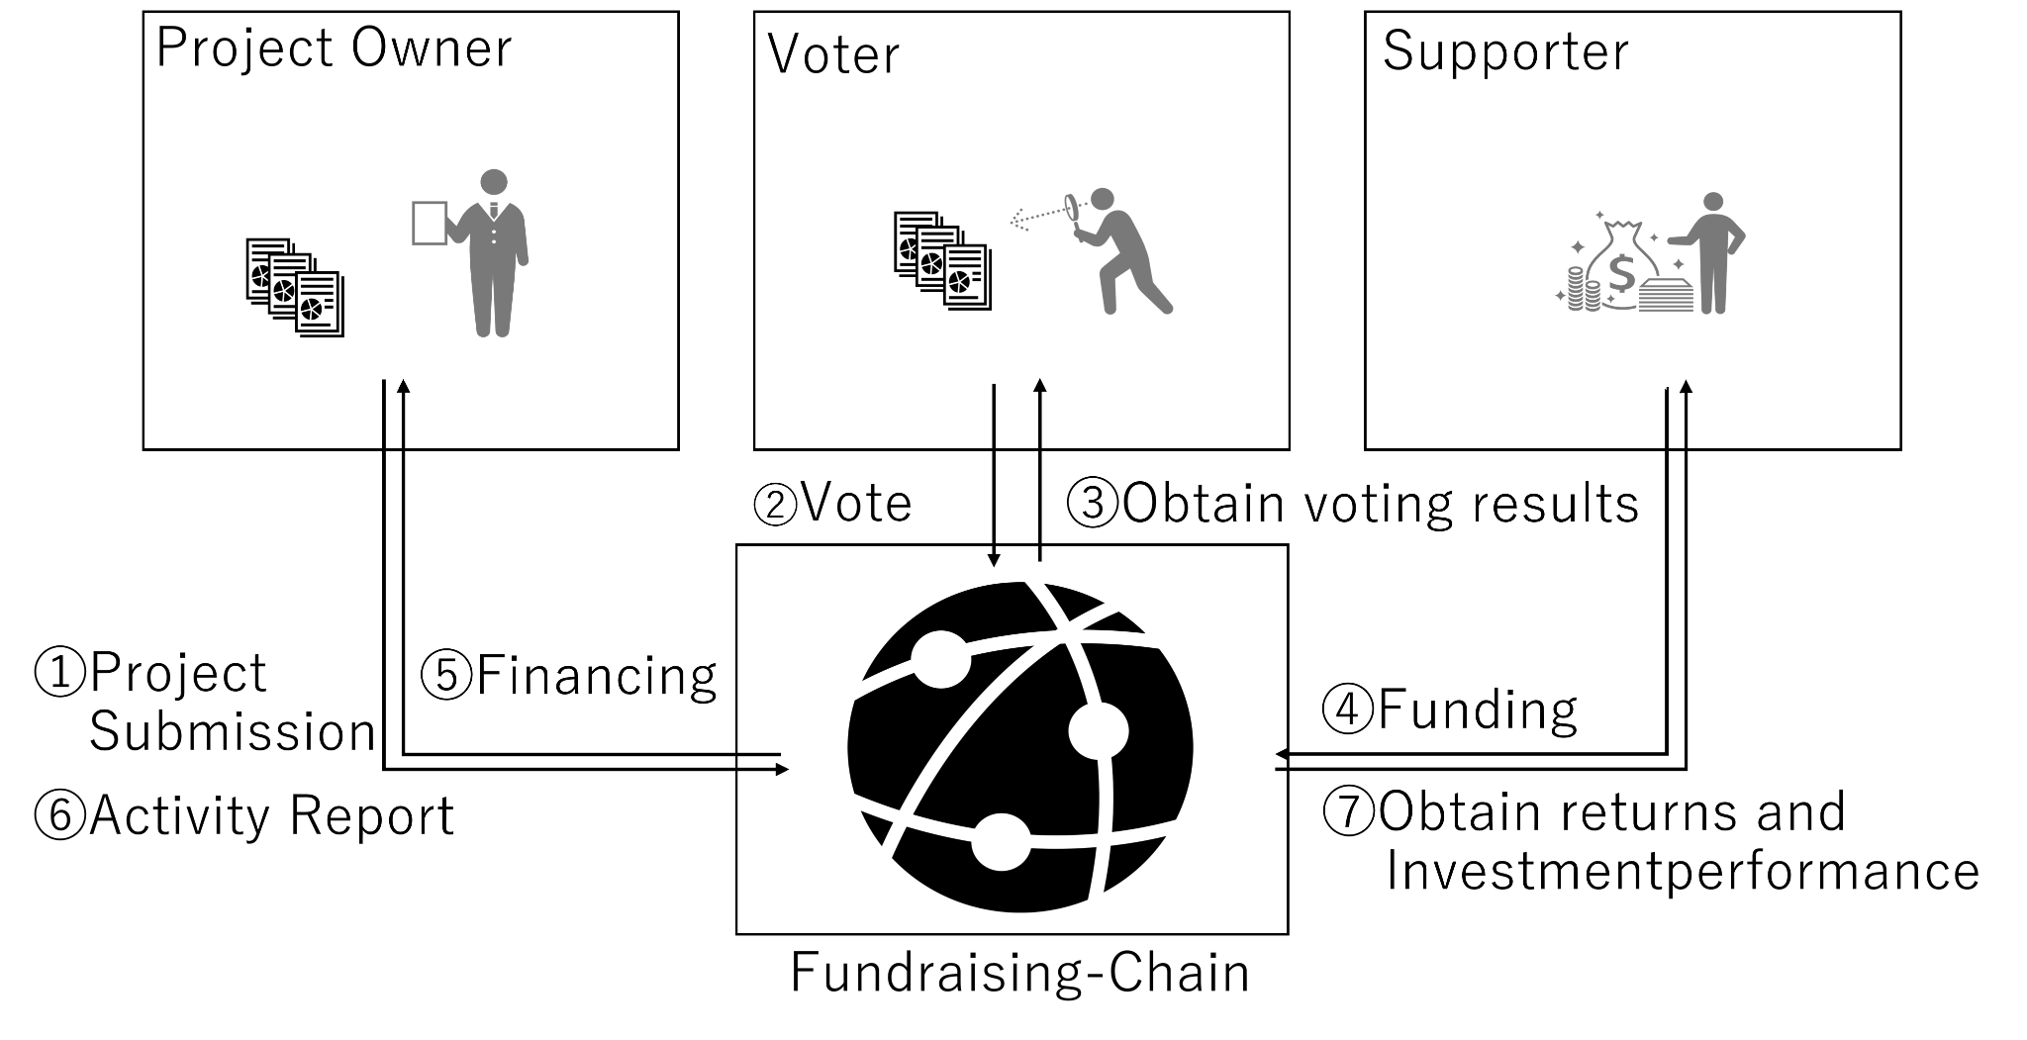

Step 2: Voting System

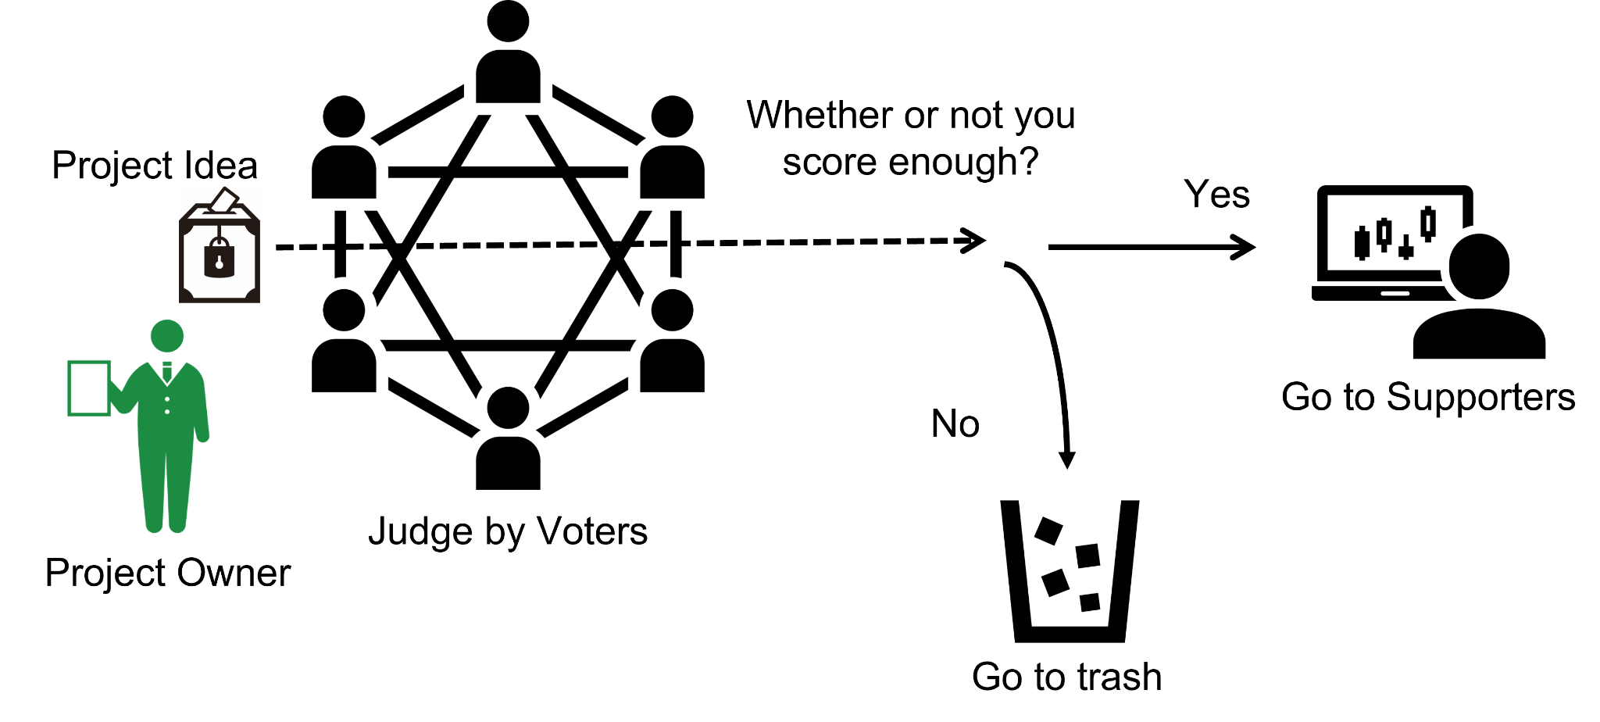

Step 3: System Overview

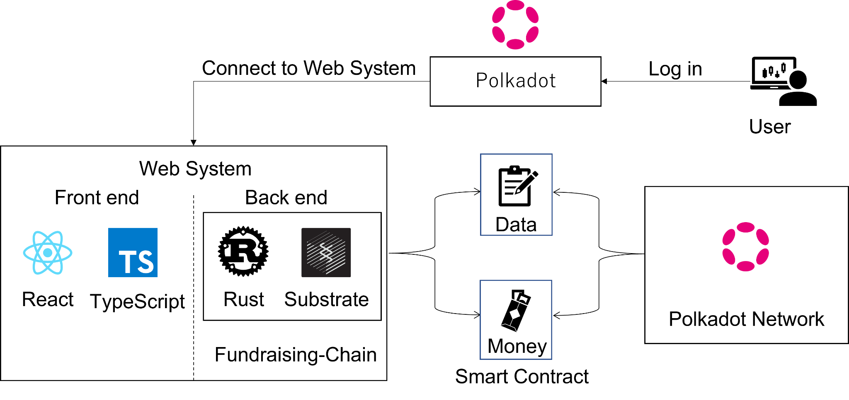

Step 4: Entity Roles

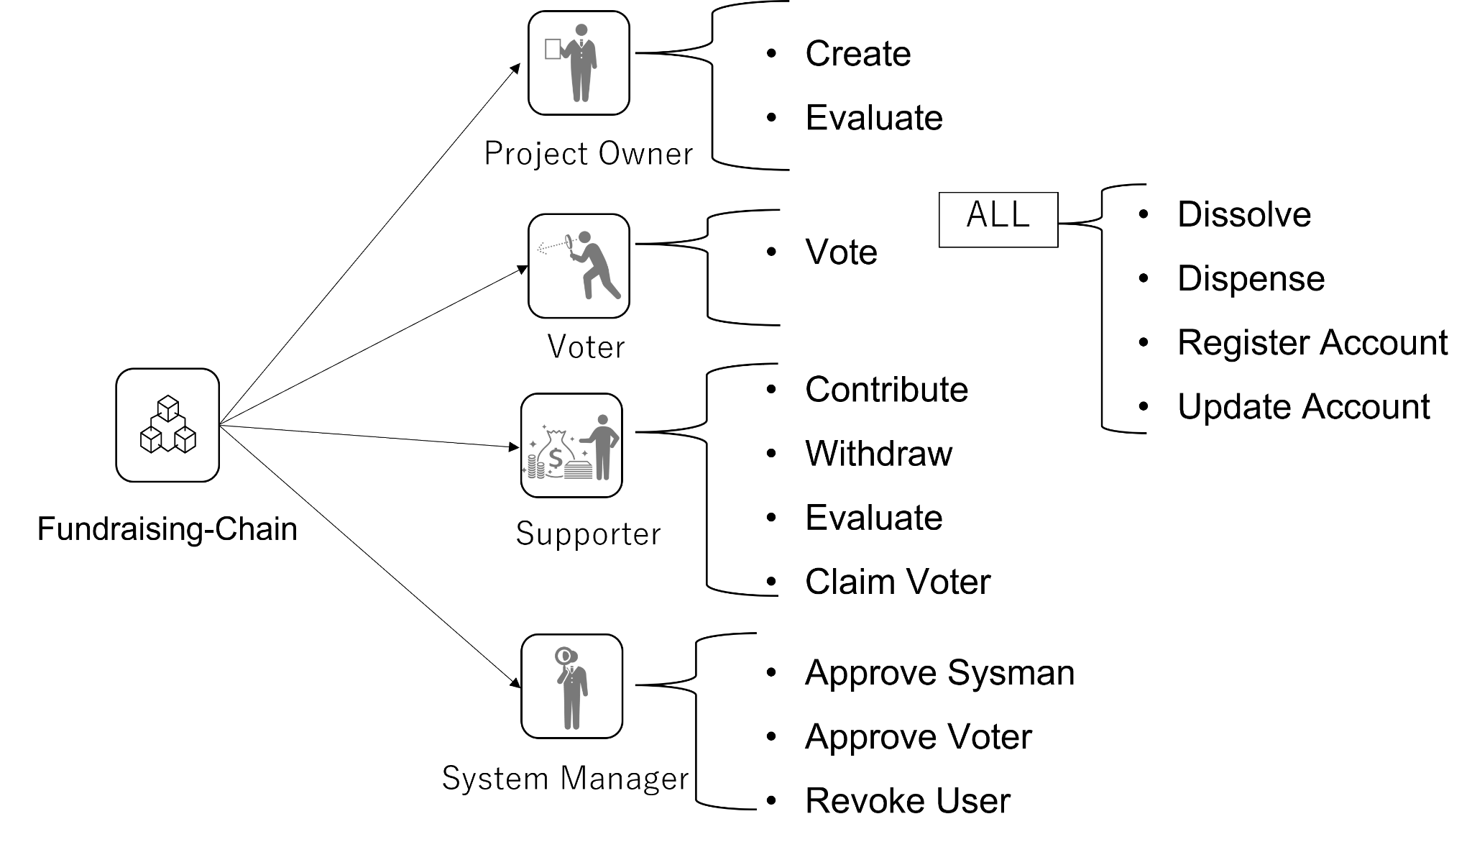

Step 5: Substrate Environment and Accounts

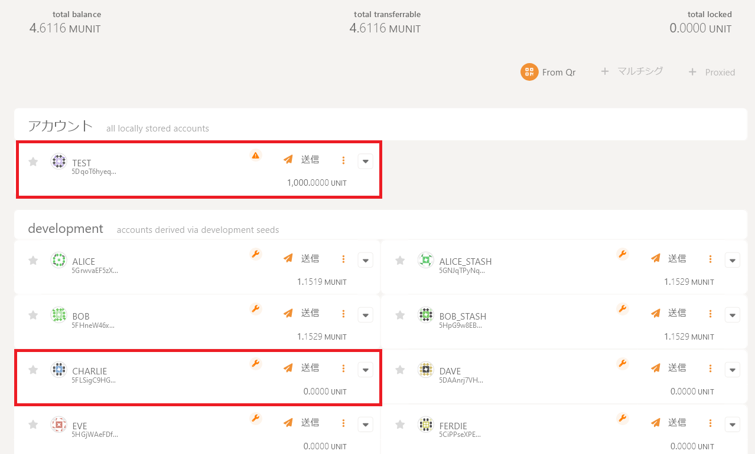

Step 6: Register Account to the Chain

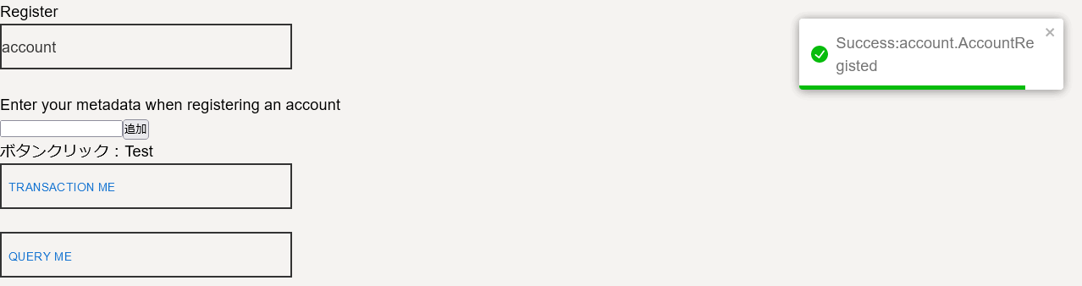

Step 7: Checking Entity to the Chain

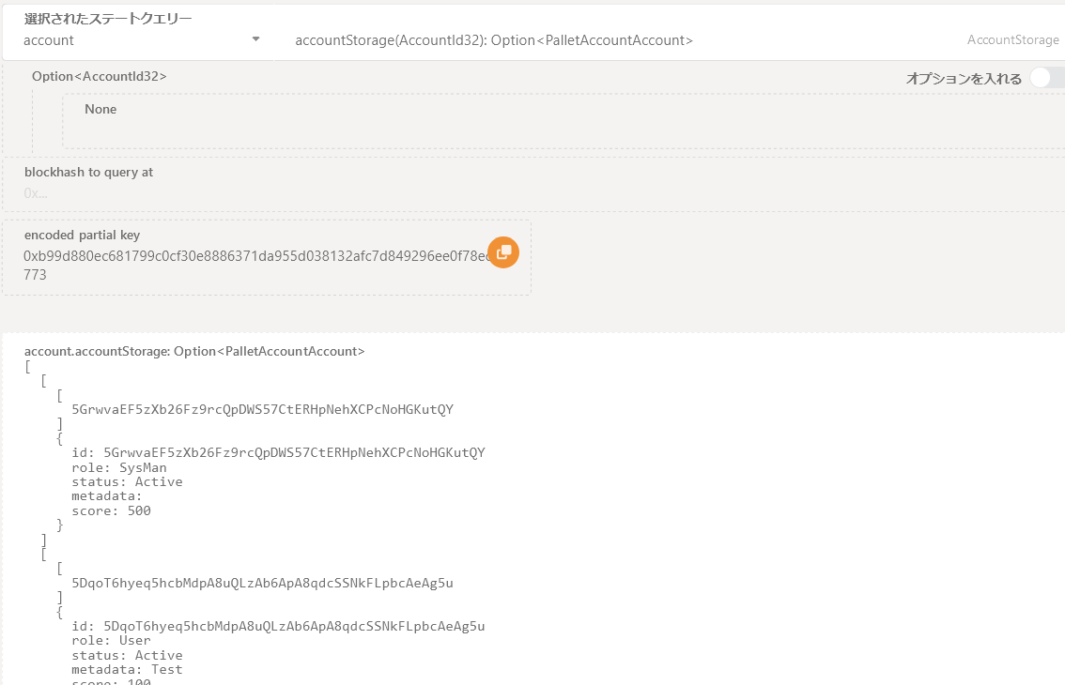

Step 8: Creating Crowed Funding Project

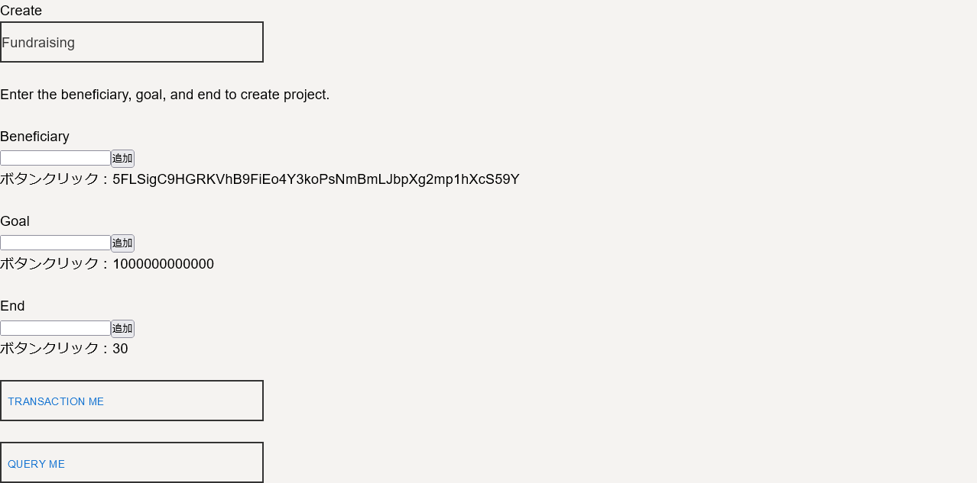

Step 9: Voting to Crowed Funding Project

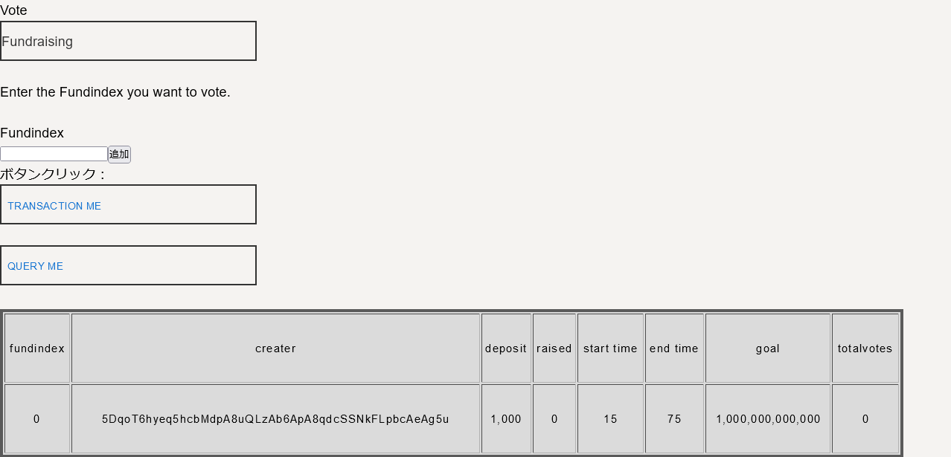

Step 10: Contribute to Crowed Funding Project

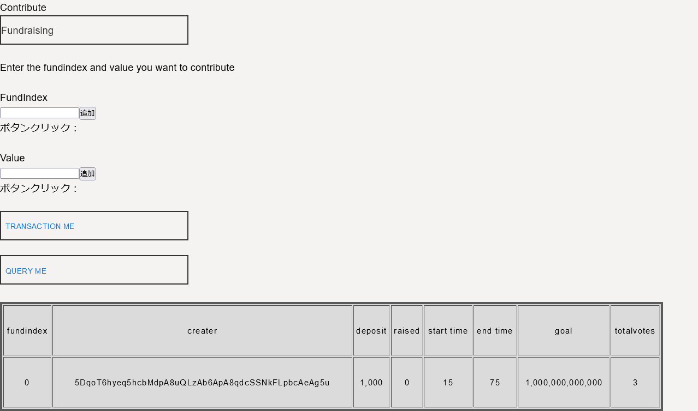

Step 11: Sending raised amount to Project Creator

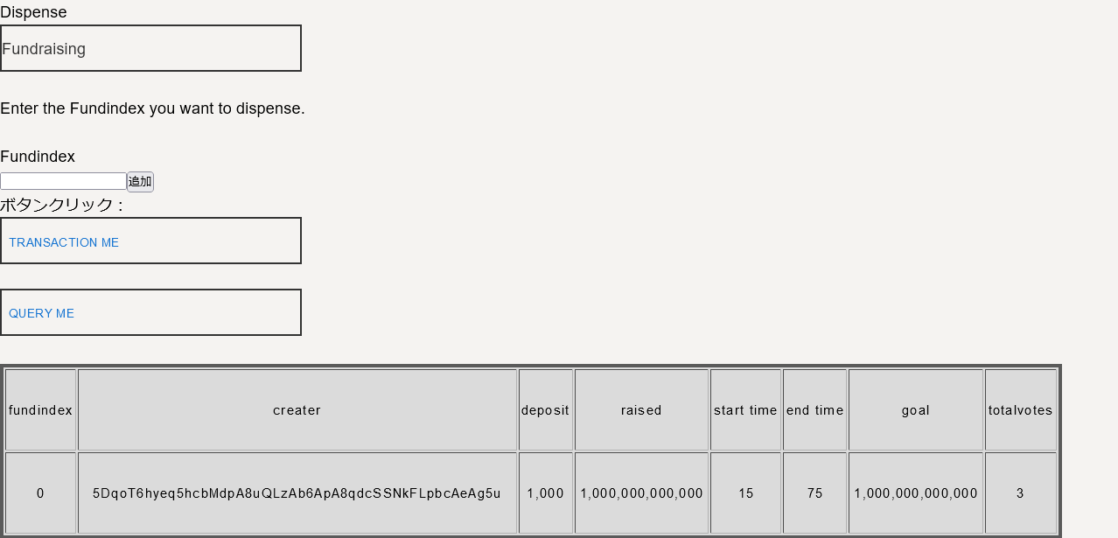

Step 12: Transaction Successfully Completed

